Ventura County General Plan 2040 comment
A chapter on Ventura County’s ocean

Ventura County has 42 miles of shoreline. Ventura County’s sea-life can continue to provide jobs, but our sea-life are threatened by climate change. Ventura County’s General Plan should consider: a) how to address sea level rising over land and b) how to help our sea-life adapt to warming water and related ocean acidification.
The people of Ventura County can leverage our unique ocean resources to save our sea-life and our way of life. Unique resources including: Channel Islands National Park “the Galapagos of the Northern Hemisphere”, California State University Channel Islands, other nearby universities, Ventura Shellfish Enterprise, OceanForesters, whale watching, sport fishing, commercial fishing, and diving.

Saving sea-life with Aqua-Forestry
Aqua-Forestry is a term that describes a complete managed ecosystem. Kelp forests are places of life and biodiversity that could be managed for food and energy in ways that support or increase animal and plant life. Fortunately, this happens naturally in kelp forests. Ominously, kelp is dying back globally off the coasts of Maine, California, and Australia. Employing Aqua-Forestry can restore past kelp forests.
The aqua-forestry concept is based on the work of Dr. Michael Chambers, University of New Hampshire, the University of Southern Mississippi, and OceanForesters.
Aqua-forestry involves natural combinations of kelp, shellfish, free-range sport fish, and crustaceans. Other coastal people may also include penned finfish. The shellfish and barnacles keep the water clear by removing microalgae, fish feces, silt, parasites, pathogens, and other organic debris. Scientists found that about 4 wet tons of shellfish and/or kelp will remove the organic nitrogen emitted by 1 ton of finfish. Kelp keeps the water clear and clean by absorbing ammonia, nitrate, and other dissolved nutrients. More shellfish or kelp would remediate water with already excessive silt and nutrients, preventing ocean dead zones and locally reducing ocean acification.
Aqua-forestry becomes the ocean resource needed by coastal communities similar to the abalone farmers in this story by National Geographic, September 2017. People will have more food plus high-tech jobs generating funds to protect the shoreline from the threat of sea level rise.
Aqua-Forestry research

The U.S. Department of Energy’s Advanced Research Project Agency-Energy has funded a program for 2018 growing kelp for energy. One team, led by the University of Southern Mississippi and whose members include Dr. Chambers and OceanForesters, are designing a structure for aqua-forestry. The name of this project is AdjustaDepth.

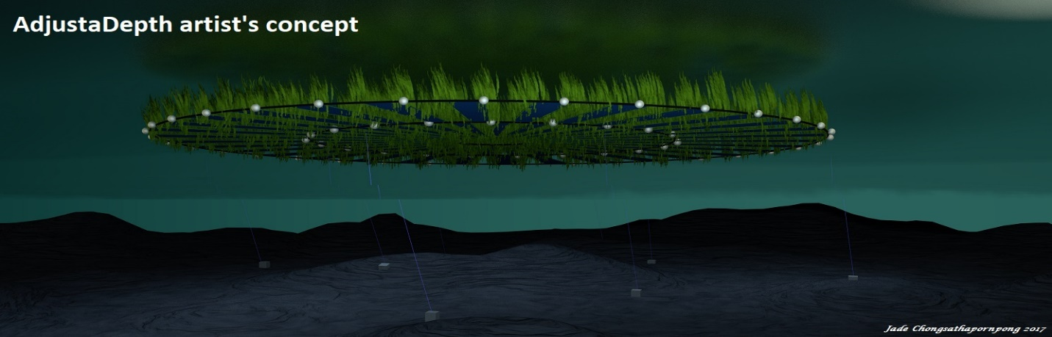

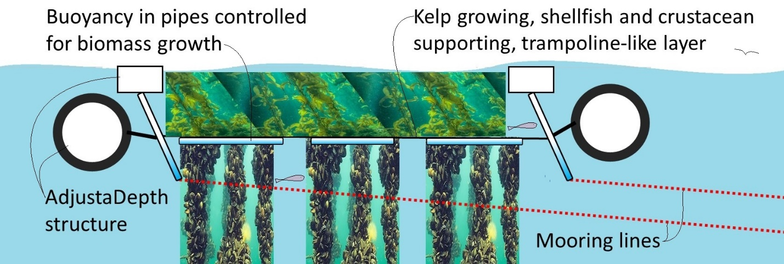

While many kinds of structures can support aqua-forestry, AdjustaDepth, see above, can change its depth allowing its plants and creatures to rest in cooler water every night, to avoid storm damage, to be more accessible for snorkeling and sport fishing, to optimize growing conditions, or to avoid ships.

Other coastal issues

OceanForesters is integrating its ocean-saving concepts with shoreline-saving concepts.

To learn more benefits of aqua-forestry and to offer comments on the design of AdjustaDepth, please contact:
Mohammed Hasan, PE, m.hasan@OceanForesters.com, (805) 218-5574
Mark Capron, PE, markcapron@OceanForesters.com, (805) 760-1967

Chapter 2. Offshore and Multi-Use Aquaculture with Extractive Species: Kelps and Bivalves, Bela H. Buck, Nancy Nevejan, Mathieu Wille, Michael D. Chambers and Thierry Chopin (2017) p. 48-51. In B.H. Buck and R. Langan (eds.), Aquaculture Perspective of Multi-Use Sites in the Open Ocean, DOI 10.1007/978-3-319-51159-7_2: http://www.springer.com/cda/content/document/cda_downloaddocument/9783319511573-c2.pdf
“Metro areas deemed most at risk (of job loss due to automation) rely on industries such as agriculture and tourism.” MIT Technology Review Jan/Feb 2018, pg 25

